COMMERCIAL OFFER
THE PATENTED SOUNDPROOF BOOTHS `SILENTBOX`
ARE A VALUABLE ADDITION TO YOUR OFFICE. Theycreatean areawhereemployeescanconcentrateon theirwork, takepersonal phone callsand distancethemselves.

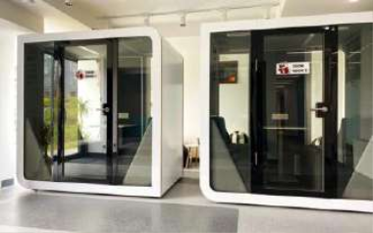
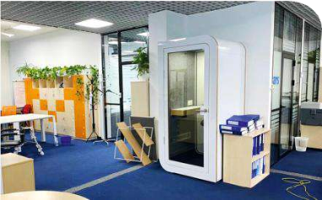
100% ECO-FRIENDLY
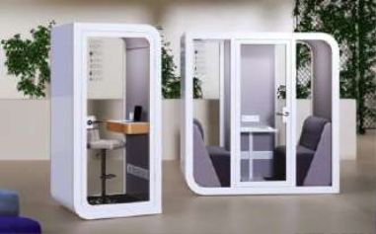
MATERIALS
dB

SOUNDPROOFING
UP TO
35

2 TO 4 WEEKS PRODUCTION TIME

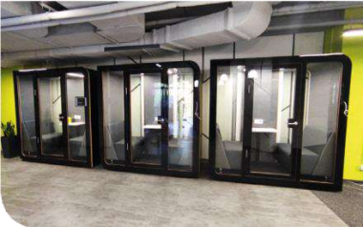
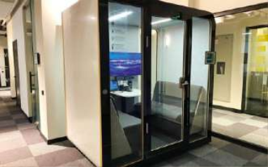
1 TO 3 HOURS INSTALLATION TIME

Investinginevena fewbooths willbe noticeablycheaperthanrentingadditionalrooms or movingto a newlocation.Silentboxbooths areefficientandmodernindesign. Theysimply blendinto the interiorof anyoffice.And best of all,it createa healthyworkingenvironment for youremployees.
TAKE YOUR CHOICE!

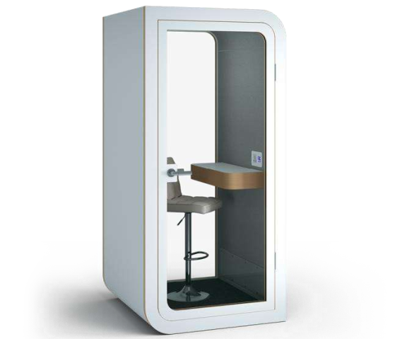
OVERVIEW VIDEO

EASY INSTALLATION

SINGLE MODEL SILENTBOX SOLO

EXTERNALDIMENSION: 110x105cm,
h=220cm

1m2 IS SUFFICIENT FOR PLACEMENT

THE SILENTBOXSOLOHAS EVERYTHINGYOUNEED FOR SMOOTHOPERATIONAND ABSOLUTECONCENTRATION -SILENTVENTILATION,USB PORTSAND A HANDY LAPTOP TABLE.

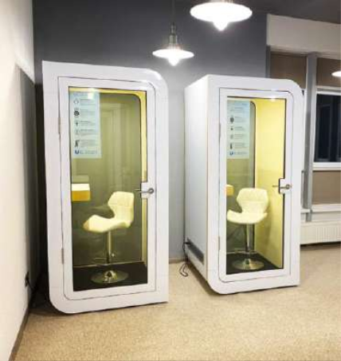
POSSIBILITYOF CUSTOMISATION

INCLUDED:
- Tablemeasuring80x30cm;
- Comfortableheight-adjustablechair; - Touch-screencontrolpanel;
- Smartlightingandventilation;
- Motionsensor,mainspanel(220V,2 usbports).

NUMBER UNITRATE
(EuroexcludingVAT)

1 4750

3 4510

5 4200

FREEBIE

Freedeliveryandassembly

Bargainprice + free delivery andassembly

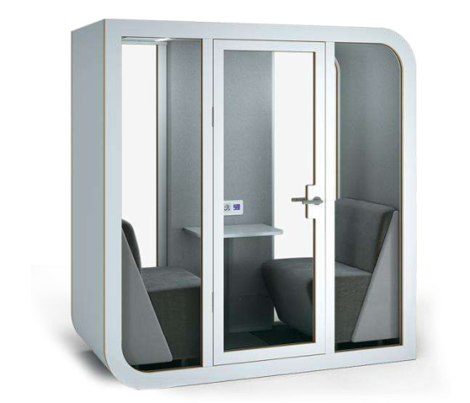
OVERVIEW VIDEO

FOR COMFORTABLE WORK
DOUBLE MODEL SILENTBOX DUET

EXTERNALDIMENSION: From210x110cm, h=220cm

MAINSPANEL USB PORT2.1A
AND 220V SOCKET

SILENTBOXDUETIS PERFECTFORPHONECALLS, VIDEOCONFERENCES,INTERVIEWS,AS WELLAS COMMUNICATIONWITHCOLLEAGUES.

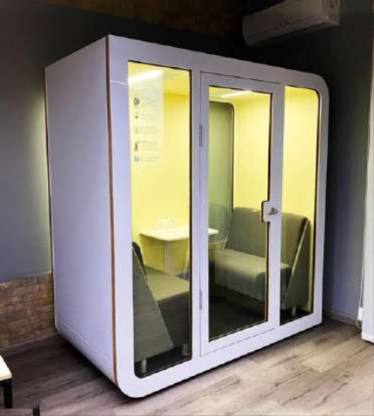
POSSIBILITYOF CUSTOMISATION

INCLUDED:
-Tablemeasuring60х45cm;
- Comfortablesofas93x66cm; - Touch-screencontrolpanel;
- Smartlightingandventilation;
- Motionsensor,mainspanel(220V,2 usbports).

NUMBER UNITRATE
(EurosexcludingVAT)

1 8450

3 8290

5 8100

10 7950

FREEBIE

Freedeliveryandassembly

Bargainprice
+ free delivery and assembly

500 colours+ bargain price best + free delivery and assembly offer

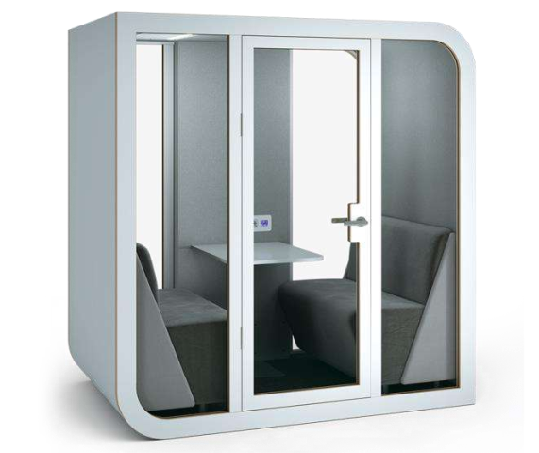
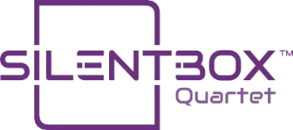
OVERVIEW VIDEO

BUSINESS MEETING PLACE

QUADRUPLE MODEL SILENTBOX QUARTET

EXTERNALDIMENSION: From210x138cm, h=220cm

VENTILATION OF
UP TO
30m3 PER HOUR

THELARGESTBOOTHMODELPROVIDESTHE PERFECT SETTINGFORBUSINESSMEETINGS,CONFIDENTIALFACE-TO-FACECONVERSATIONS,BRAINSTORMINGSESSIONS AND INTERVIEWS.

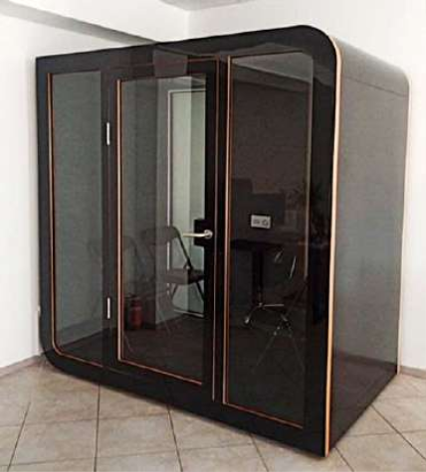
POSSIBILITYOF CUSTOMISATION

INCLUDED:
- Tablemeasuring60х60cm;
- Comfortablesofas120х66cm; - Touch-screencontrolpanel;
- Smartlightingandventilation;
- Motionsensor,mainspanel(220V,2 usbports).

NUMBER UNITRATE
(EuroexcludingVAT)

1 9150

3 8980

5 8750

10 8600

FREEBIE

Freedeliveryandassembly

Bargainprice
+ free delivery and assembly

500 colours+ bargain price + free delivery and assembly

best offer

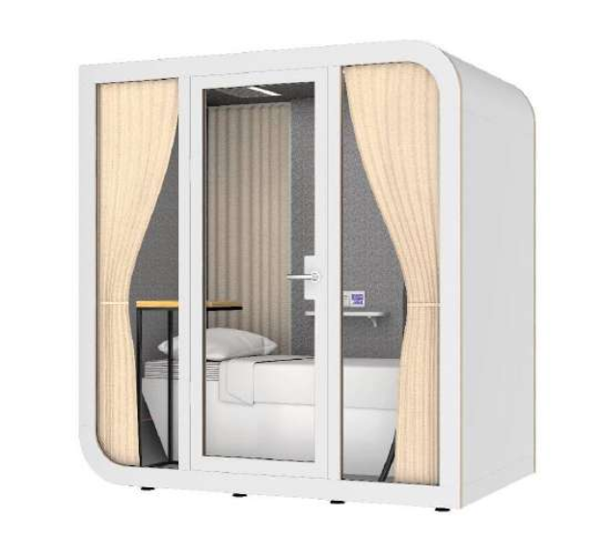
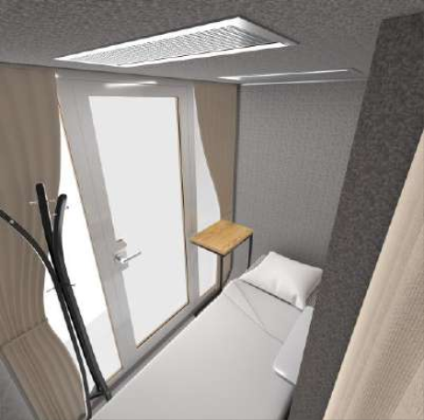
MODEL DESCRIPTION Sleep

SLEEPING CABIN
SINGLE MODEL SILENTBOX SLEEP

EXTERNALDIMENSION: From210x138cm, h=220cm

PERFECT SILENCE
FOR HEALTHY
SLEEP

THEBESTSOLUTIONFORAN OFFICERESTAREA THAT MINIMIZESSLEEPLACK AND IMPROVESWORKERS' HEALTHAND WELL-BEING.

POSSIBILITYOF CUSTOMISATION

INCLUDED:
- Tablemeasuring30х40cm; - Comfortablebed190х90cm; - Touch-screencontrolpanel;
- Smartlightingandventilation;
- Motionsensor,mainspanel(220V,2 usbports).

NUMBER UNITRATE
(EuroexcludingVAT)

1 8100

3 8000

5 7900

10 7700

FREEBIE

Freedeliveryandassembly

Bargainprice
+ free delivery and assembly

500 colours+ bargain price best + free delivery and assembly offer

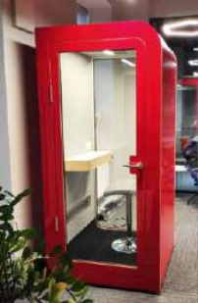
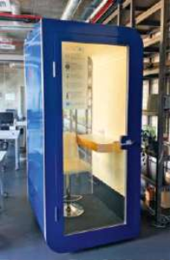
CUSTOMISATION
You can choose the external colour of the booths from the 10 available options or order the design to match your corporate identity. A choice of interior colour is also available - ofthe eightoptionsavailable.

BOOTHS WARRANTY 12 MONTHS!

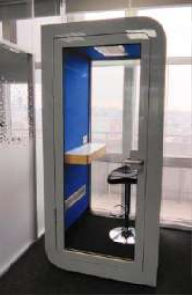
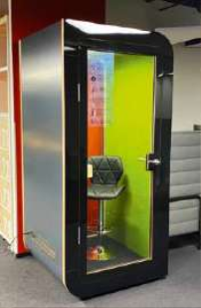
Each Silentbox acoustic model represents a profitable investment based on the improvement it makes to the overall performanceandhealthofyourstaff.

The ability to enter a silent room is an important factor in building the confidence of your workers. They will feel relief fromthestressthatanopen-planofficecreates.

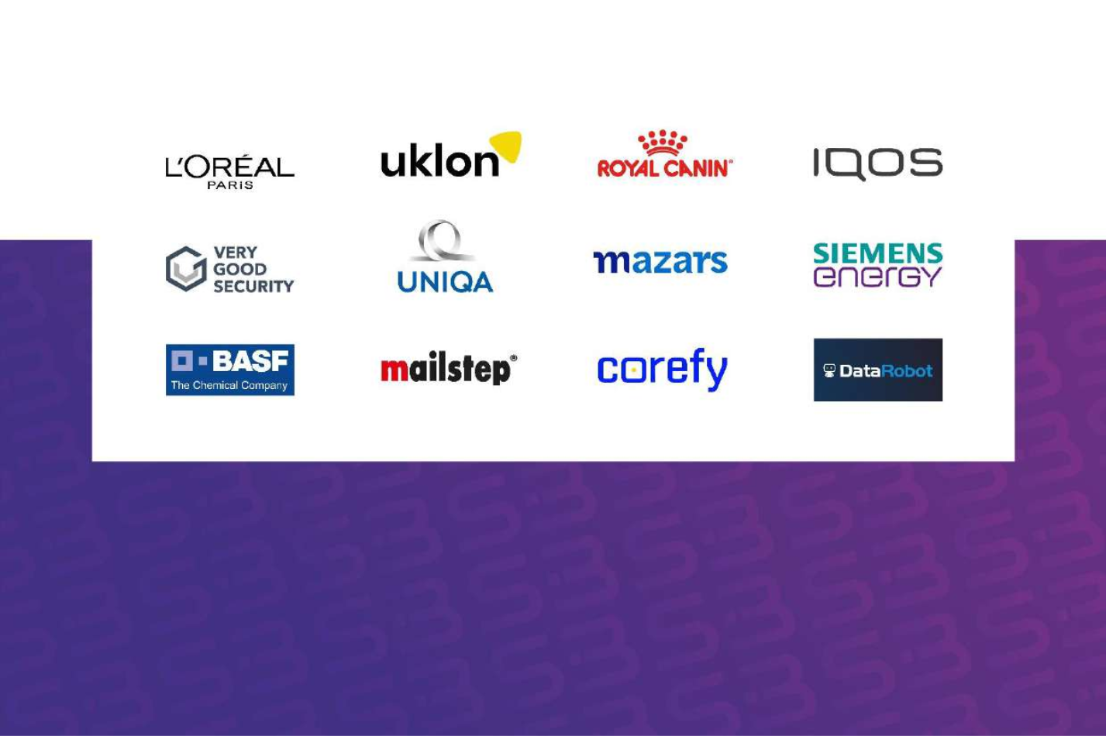
OUR BOOTHS ARE INSTALLED IN COMPANY OFFICES:

Contact us: +48 664 303 521
Email:
info@silent-box.com

You cantest Silentboxpod in showroomsin Prague andTallinn.

